**Topics: Descriptive Statistics and Probability**

1. Look at the data given below. Plot the data, find the outliers and find out $μ, σ, σ^{2}$

|  |  |
| --- | --- |
| **Name of company** | **Measure X** |
| Allied Signal | 24.23% |
| Bankers Trust | 25.53% |
| General Mills | 25.41% |
| ITT Industries | 24.14% |
| J.P.Morgan & Co. | 29.62% |
| Lehman Brothers | 28.25% |
| Marriott | 25.81% |
| MCI | 24.39% |
| Merrill Lynch | 40.26% |
| Microsoft | 32.95% |
| Morgan Stanley | 91.36% |
| Sun Microsystems | 25.99% |
| Travelers | 39.42% |
| US Airways | 26.71% |
| Warner-Lambert | 35.00% |

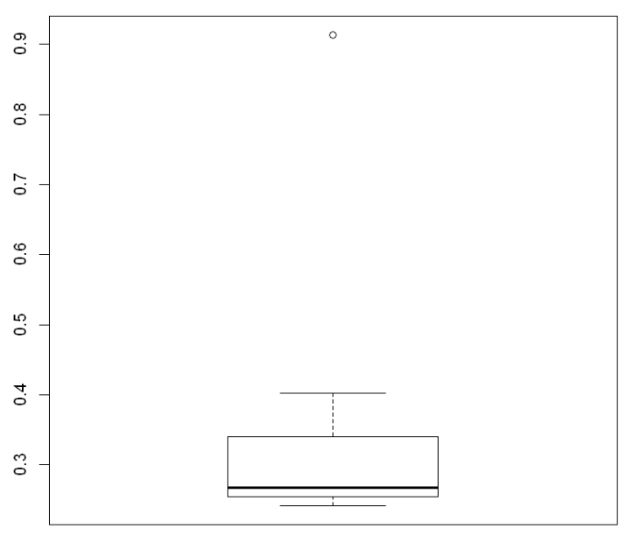

Mean = 0.332713333333333

Sd = 0.16945400921222

Var = 0.0287146612380952



Answer the following three questions based on the box-plot above.

1. What is inter-quartile range of this dataset? (please approximate the numbers) In one line, explain what this value implies.

Ans: Approximately (First Quantile Range) Q1 = 5 (Third Quantile Range) Q3 = 12, Median (Second Quartile Range) = 7

(Inter-Quartile Range) IQR = Q3 – Q1 = 12 – 5 = 7

Second Quartile Range is the Median Value

50% of the data lies between IQR

1. What can we say about the skewness of this dataset?

Ans: Right-Skewed median is towards the left side it is not normal distribution

1. If it was found that the data point with the value 25 is actually 2.5, how would the new box-plot be affected?

Ans: In that case there would be no Outliers on the given dataset because of the outlier the data had positive skewness it will reduce and the data will normal distributed



Answer the following three questions based on the histogram above.

1. Where would the mode of this dataset lie?

Ans: The mode of this data set lie in between 5 to 10 and approximately between 4 to 8 .

1. Comment on the skewness of the dataset.

Ans: Right-Skewed. Mean>Median>Mode

1. Suppose that the above histogram and the box-plot in question 2 are plotted for the same dataset. Explain how these graphs complement each other in providing information about any dataset.

Ans: They both are right-skewed and both have outliers the median can be easily visualized in box plot where as in histogram mode is more visible.

1. AT&T was running commercials in 1990 aimed at luring back customers who had switched to one of the other long-distance phone service providers. One such commercial shows a businessman trying to reach Phoenix and mistakenly getting Fiji, where a half-naked native on a beach responds incomprehensibly in Polynesian. When asked about this advertisement, AT&T admitted that the portrayed incident did not actually take place but added that this was an enactment of something that “could happen.” Suppose that one in 200 long-distance telephone calls is misdirected. What is the probability that at least one in five attempted telephone calls reaches the wrong number? (Assume independence of attempts.)

**Ans:** One wrong number out of 200 Probability of wrong number: P(WN) = 1/200 = 0.005 Probability of not wrong number: 1 - P(WN) = (1- 1/200) = 0.995

Number of Calls = 5

P(x) = ⁿCₓ p ˣ qⁿ⁻ˣ

n = 5

p = 1/200

q = 199/200

at least one in five attempted telephone calls reaches the wrong number

= 1 - none of the call reaches the wrong number

= 1 – P (0)

= 1 - ⁵ C ₀ (1/ 200 ) ⁰(199/200)⁵⁻⁰

= 1 - (199/ 200 )⁵

= 0.0247

1. Returns on a certain business venture, to the nearest $1,000, are known to follow the following probability distribution

|  |  |
| --- | --- |
| x | P(x) |
| -2,000 | 0.1 |
| -1,000 | 0.1 |
| 0 | 0.2 |
| 1000 | 0.2 |
| 2000 | 0.3 |
| 3000 | 0.1 |

1. What is the most likely monetary outcome of the business venture?

Ans: for x = 2000, the value of P(X) most. Hence, the most likely monetary

1. Is the venture likely to be successful? Explain

Ans: P(x>0)=0.2+0.3+0.1=0.6 means the venture would give profit or expected returns.

1. What is the long-term average earning of business ventures of this kind? Explain

Ans: Weighted average = x*P(x) = 800. This means the average expected earnings over a long period of time would be 800(including all losses and gains over the period of time)

1. What is the good measure of the risk involved in a venture of this kind? Compute this measure

P(loss) = P(x= -2000)+P(x=-1000)=0.2

20% risk.